The Structural Basis for the Brilliant Colors of the Sapphirinid Copepods and the Neon Tetra Fish
Dvir Gur¹, Ben Leshem², Maria Pierantoni¹, Viviana Farstey³, Dan Oron², Steve Weiner¹, Lia Addadi¹
¹Dept. of Structural Biology, Weizmann Institute of Science, Rehovot, 76100, Israel
²Dept. of Physics of Complex Systems, Weizmann Institute of Science, Rehovot, 76100, Israel
³The Interuniversity Institute for Marine Sciences, Eilat, Israel

In animals colors are produced by either pigment coloration or structural colors. Structural colors are caused by the interaction of light with structures that have periodicities comparable to the visible light wavelengths. This leads to selective reflection of particular wavelengths through interference. Many taxa have independently evolved ways to produce structural colors using intra-cellular arrays of guanine crystals interspersed with cytoplasm (1, 2). One of the most striking examples of such photonic arrays are the male sapphirinid copepods, small marine crustaceans that produce a variety of different colors. In order to understand how the different colors are produced, we designed a fully correlative experiment in which the reflectance of individual copepods was first measured using a tailor made microscope, and then the thicknesses of the crystal and cytoplasm layers were measured using cryo-SEM on the same individuals. Using this approach we were able to demonstrate that variations in cytoplasm layer thickness are mainly responsible for the different reflected colors (Fig.1). Furthermore, we show a strong angular dependence of the copepod color on the orientation relative to the incident light, which can account for its appearance and disappearance during spiral swimming in the natural habitat (3).
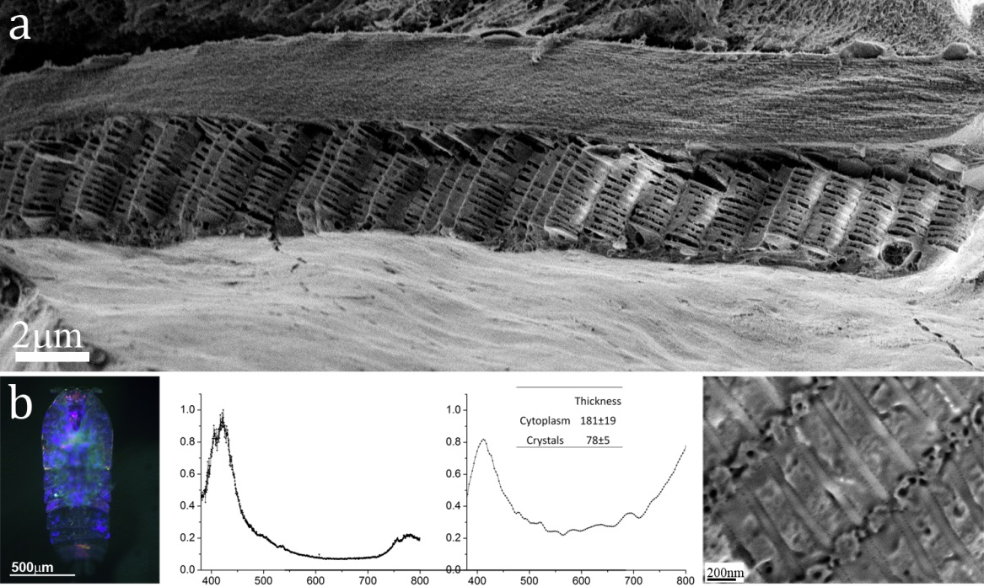
Figure 1. a) Cryo-SEM micrographs of high pressure frozen, freeze fractured S. metallina copepod. b) Reflectance and structural properties of an individual copepod Column 1 (left) shows light microscope images of representative sapphirinid male specimens, and column 2 the measured reflectance. Column 4 shows a representative cryo-SEM image of the crystal – cytoplasm layer arrays, and column 3 the calculated reflectance.
In many of the systems the spacing of guanine crystals and cytoplasm are immobile, but
there are a few known cases where they are not. The Neon Tetra fish changes its structural color of its lateral stripe from blue-green to indigo in response to different light stimuli (Fig.2). Lythgoe & Shand suggested that the variation in spacing is due to a change in osmotic pressure, which results in the inflow of water into the guanophore (specialized cells containing guanine crystals)(4). This inflow of water leads to swelling of the guanophore cell and consequently to an increase in crystal spacing. In contrast, Nagaishi et al suggested that the tilt angle of the crystal platelet varies, leading to a change in platelet spacing (5). Using synchrotron radiation combined with data from cryo-SEM, we were able to determine that the change in the color of the lateral stripe of the Neon is due to an angular shift of the guanine crystals. This angular shift results in a change in the d spacings between the crystals.

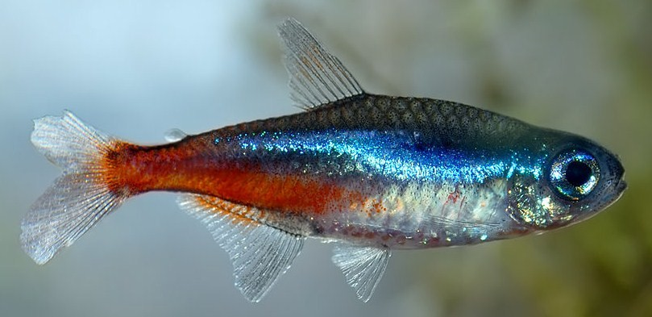
Figure 2. Image of Neon Tetra fish, showing the blue lateral stripe ( Image adopted from http://bettatrading.com.au/Neon-Tetra-Fact-Sheet.php)

Reference:

1. A. R. Parker, 515 million years of structural colour. J. Opt. A: Pure Appl. Opt. 2, R15 (2000).
2. D. Gur, B. Leshem, D. Oron, S. Weiner, L. Addadi, The structural basis for enhanced silver reflectance in Koi fish scale and skin. J. Am. Chem. Soc. 136, 17236 (Dec 20, 2014).
3. D. Gur et al., The Structural Basis for the Brilliant Colors of the Sapphirinid Copepods (Submited, 2015).
4. J. N. Lythgoe , J. Shand, The Structural Basis for Iridescent Colour Changes in Dermal and Corneal Irddophores in Fish. J. Exp. Biol. 141, 313 (1989).
5. H. Nagaishi, N. Oshima, Ultrastructure of the Motile Iridophores of the Neon Tetra. Zool. Sci. 9, 65 (Feb, 1992).

